**CHAPTER 7**

**SCREENSHOTS**

**7.1 OUTPUT SCREENSHOTS**

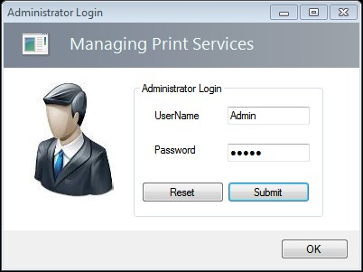

**Figure 7.1 Administrator Login**

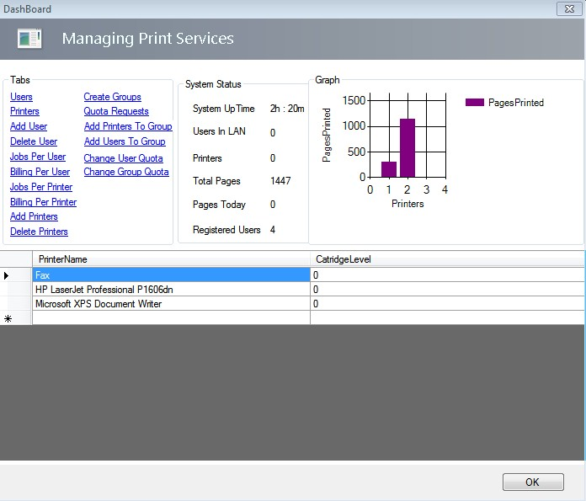

**Figure 7.2 Dashboard**

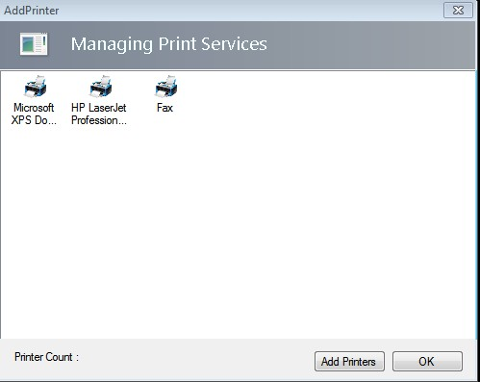

**Figure 7.3 Adding a new printer**

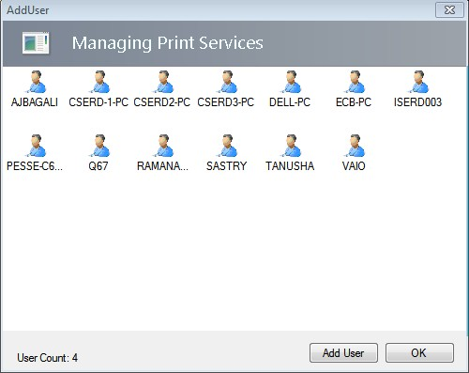

**Figure 7.4 Adding new users**

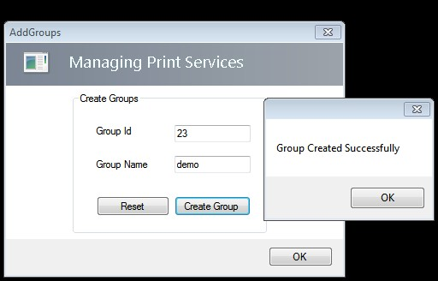

**Figure 7.5 Creating new groups**

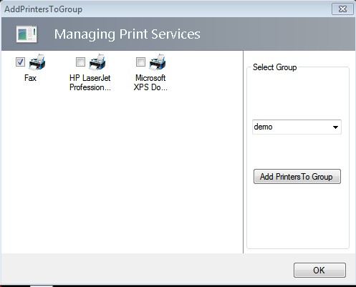

**Figure 7.6 Adding printers to groups**

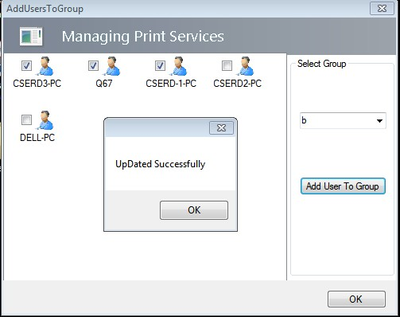

**Figure 7.7 Adding users to groups**

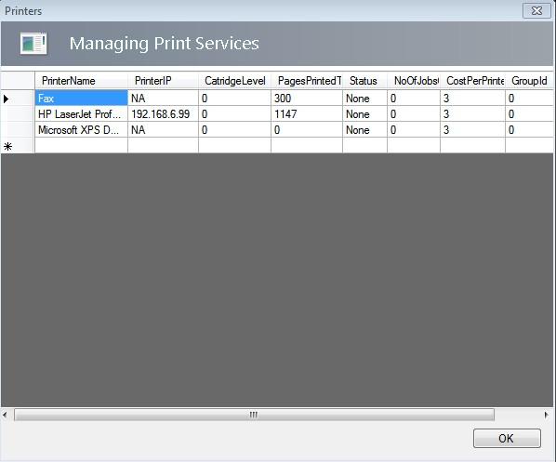

**Figure 7.8 View printer statistics**

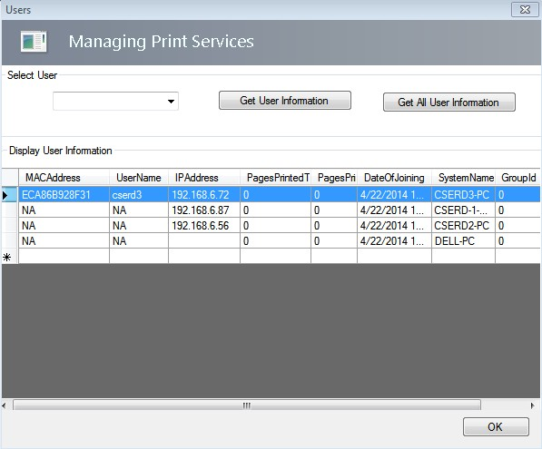

**Figure 7.9 View user statistics**

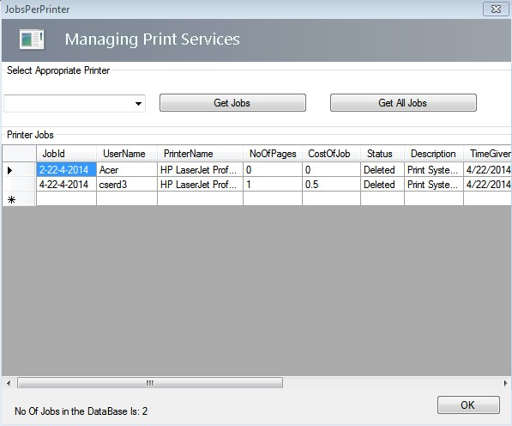

**Figure 7.10 View jobs per printer**

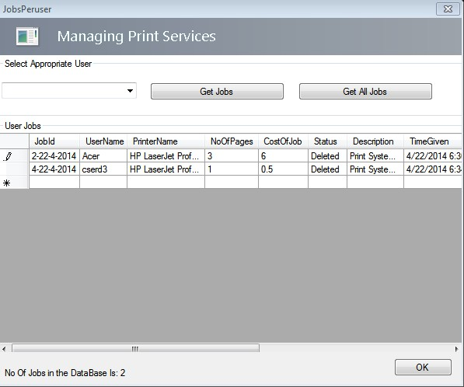

**Figure 7.11 View jobs per user**

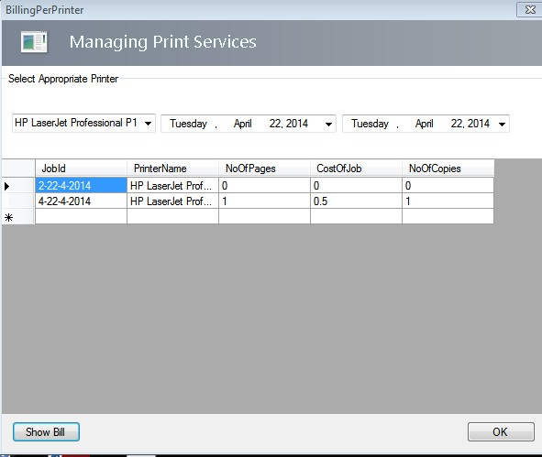

**Figure 7.12 Generate bill per printer**

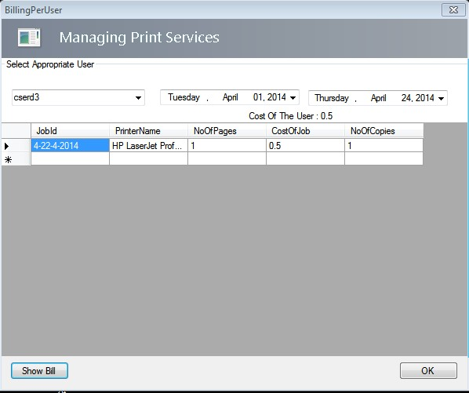

**Figure 7.13 Generate bill per user**

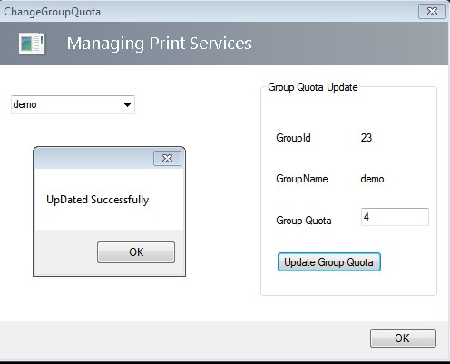

**Figure 7.14 Change group quota**

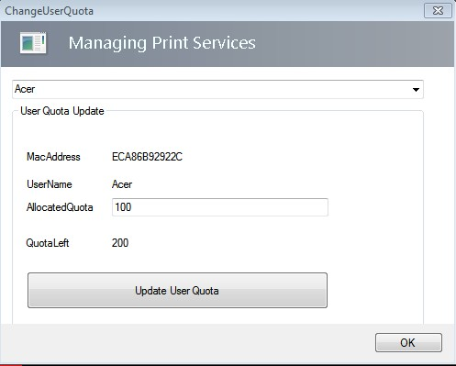

**Figure 7.15 Change user quota**

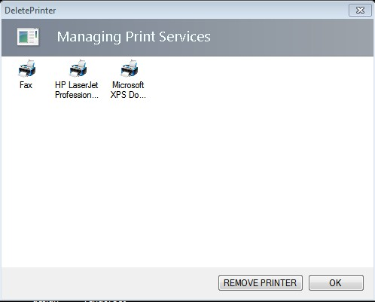

**Figure 7.16 Delete printer**

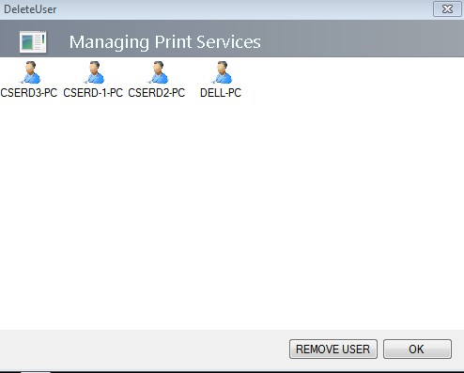

**Figure 7.17 Delete user**

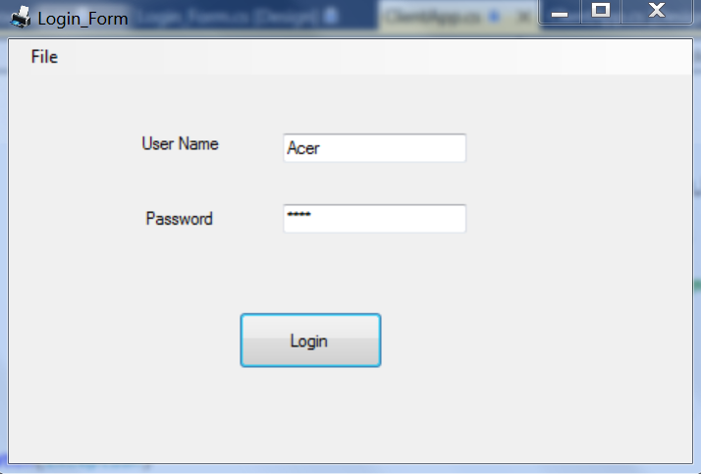

**Figure 7.18 Client login**

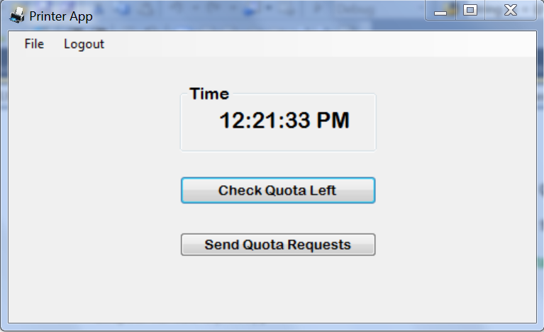

**Figure 7.19 Client details**

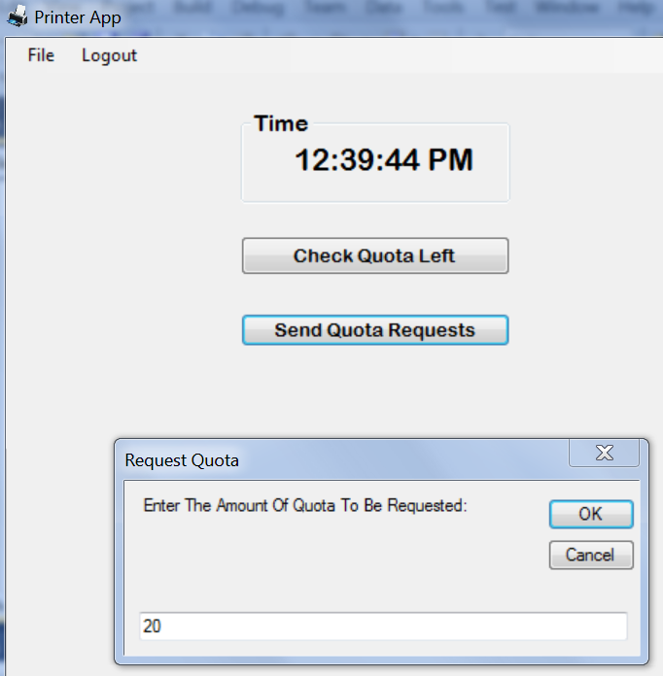

**Figure 7.20 Request quota**